What you need
Install
- IIS
- Then VS2003 (installs .Net 1.13?) (for the Salt project)
Then VS2005 (for the SALT_LanguageDeveloperAssistant project)?

You need a server with
- SQL2005 (Transaction Server)
- SQL2000 Reporting Services (Reporting Server)

In production the Reporting Server contains a copy of the transaction server data (replicated from the transactions server)

The default test environment has been installed on the BDWTEST/TS SQL server instance (schizo Virtual Machine), SQL login name = salt_user, password = password
(Reporting Services on BDWTEST/RS and http://bdwtest/ReportServer)
Integrated authentication.
The current development environment is a VM (VDLVM) - windows XP (can’t use VISTA?) with IIS, VS2003 and VS2005

The current installation test environments are VM’s:
W2K3IISRS – reporting Server – login sa , password w2k3iisrs database ‘a’
W2K3IISTS – transaction Server – login sa , password w2k3iists database ‘b’ (for upgrades or database ‘c’ for new installs)
Administrator password for W2K3IISTS is TcsotM08, need to run the installer on the TS(Transaction Server)

BDWTEST\RS login sa password bdwtestrs

Source code.
Salt is maintained in Visual Sourcesafe:
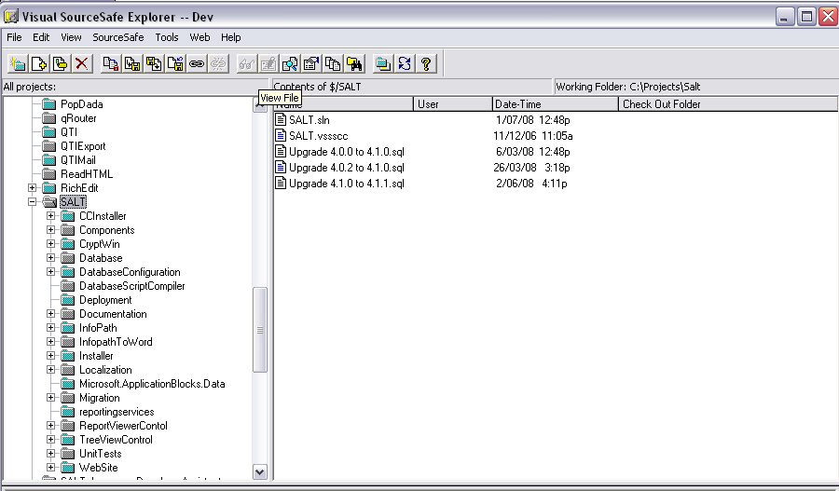

SALT_LanguageDeveloperAssistant is maintained in Visual Sourcesafe
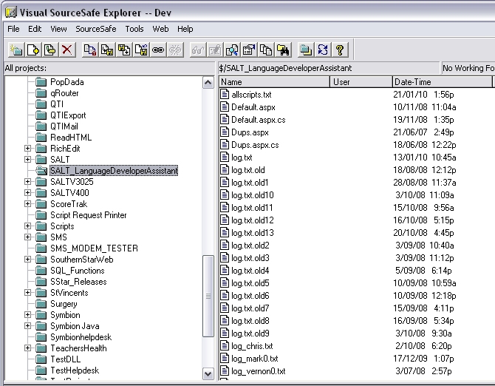
versions are unknown.

Lessons were previously (v3.0) developed using ToolBook, lessons communicate results to the website using a ToolBookListener and ToolBook XSD:
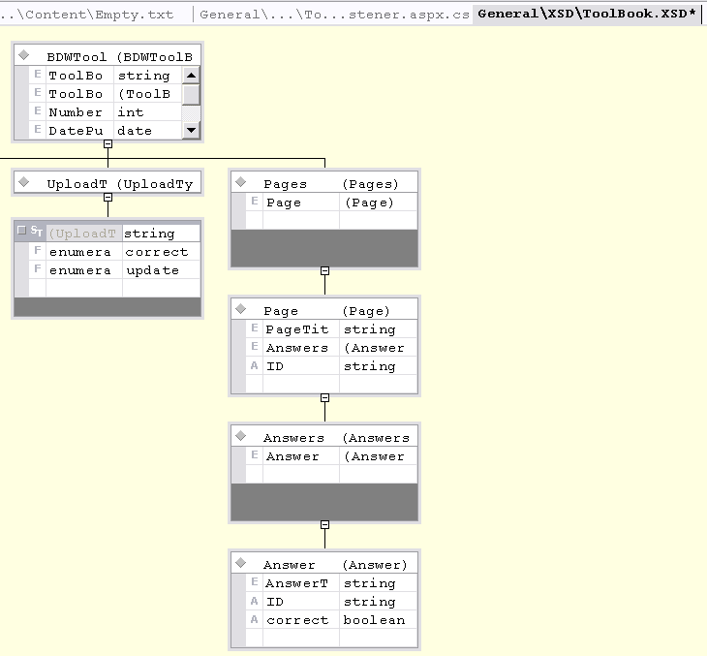

More details will be provided when the design document that discusses Toolbook is located:

ToolBook Integration
Currently in a supplement document

In version 3.5 Infopath was introduced to prepare (and display?) lessons (part of MS Office) because “Toolbook utilizes technologies which create dependencies on the client environment. This situation is unacceptable to BDW. “

User Classes
- SALT ADMINISTRATOR
- Organisation Administrator
- Unit Administrator
- Normal Student

Unit Administrators are:
  - automatically assigned to courses and policies
  - able to be assigned to either a unit AND the sub-units of that unit or just the unit and not the sub-units
  - The administrators that are emailed from the email reports.
  - If no Unit Administrator exists for a unit then the organisation administrator/s are emailed instead

DomainName
Make sure you change the DomainName of the orgs that you intend to use if you access the website with a different URL – eg moving from localhost to //mike needs the DomainNames changed.

TblUnitHierarchy
was on RS only – now on both RS and TS

WTF - Duplication of username is allowed.
Login password must match top 1 tbluser.UserName !!!!!

How to check out a Visual Studio website project on a new VM or PC (specifically the SALT website) (So that the website is installed IN THE ROOT)
Create a COMPLETELY EMPTY DIRECTORY
In IIS Point the default website to the COMPLETELY EMPTY DIRECTORY
Delete SALT.SUO (rename it if you like)
Check out the source code in VisStudio with a URL of http://localhost
At some point mark the website as an application so you can debug it

Why is SALT in the ROOT of the website.
Infopath publishing copies files to directories that are specified as ABSOLUTE with respect to the ROOT of the website -“/general/Infopath...” (not relative to the salt website location - “../../../../general/infopath”). References to infopath directories are LOCALISED so you will need to modify all of the data in langvalue (in other languages also)

Default collation
SQL 7.0 = 'Latin1_General_CI_AS'
SQL2000,2005,2008,2010 = 'SQL_Latin1_General_CP1_CI_AI'

SALT 4.1.5 = 'Latin1_General_CI_AS'?
Salt does joins to the temp database with “=” so collations on both databases must be the same!!

- When installing a clean server instance set it's default collation to 'Latin1_General_CI_AS'

Where is the connection specified in the project:
C:\Projects\Salt\WWWROOT_4.1.5 Release\Reporting\Admin\Web.config
C:\Projects\Salt\WWWROOT_4.1.5 Release\Reporting\CPD\Web.config
C:\Projects\Salt\WWWROOT_4.1.5 Release\Reporting\Email\Web.config
C:\Projects\Salt\WWWROOT_4.1.5 Release\Reporting\Email\Web.config
C:\Projects\Salt\WWWROOT_4.1.5 Release\Web.config

